**Lab 16**

**Name :-** Aryan Dilipbhai Langhanoja

**Date :-** 25-09-2023

**Enrollment No :-** 92200133030

**CO1: To write, test, and debug simple Python programs**

**CO2: To implement Python programs with conditional, loops and functions**

**Task 1:- Frequency Spectrum Analysis of Sample Data using FFT**

**Python Code:**

import numpy as np

import matplotlib.pyplot as plt

from scipy import fftpack

fre_samp = 100 # Sample frequency in Hz

t = np.arange(0, 1, 1/fre_samp) # Time vector

A = 5 * np.sin(2 * np.pi * 50 * t) + 2 * np.sin(2 * np.pi * 120 * t)

A_fft = fftpack.fft(A)

frequency = fftpack.fftfreq(len(A), 1 / fre_samp)

plt.stem(frequency, np.abs(A_fft), use_line_collection=True)

plt.xlabel('Frequency in Hz')

plt.ylabel('Frequency Spectrum Magnitude')

plt.show()

**Output:**

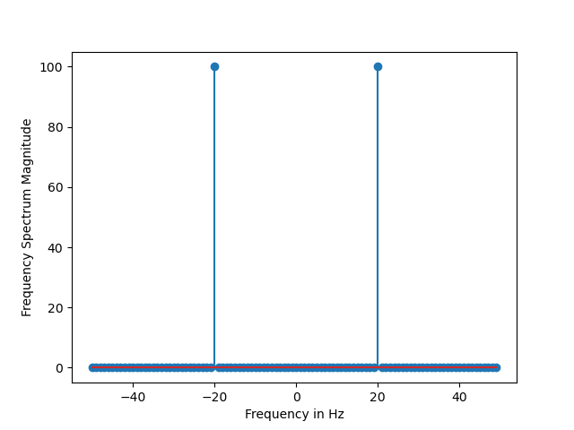

**Task 2:- Numerical Integration of a Gaussian Function Using SciPy**

**Python Code:**

from numpy import exp

import scipy.integrate

def f(x): return exp(-x**2)

i = scipy.integrate.quad(f, 0, 1)

print(i)

**Output:**



**Task 3:- Double Integration of a Function over a Rectangular Region**

**Python Code:**

import scipy.integrate

from numpy import exp

from math import sqrt

def f(x, y): return 2*x*y

def g(x): return 0

def h(y): return 4*y**2

i = scipy.integrate.dblquad(f, 0, 0.5, g, h)

print(i)

**Output:**



**Task 4:- Double Integration of a Function over a Rectangular Region**

**Python Code:**

import numpy as np

from scipy import interpolate

import matplotlib.pyplot as plt

x = np.linspace(0, 5, 10)

y = np.cos(x**2/3+4)

plt.scatter(x,y,c='r')

plt.show()

**Output:**

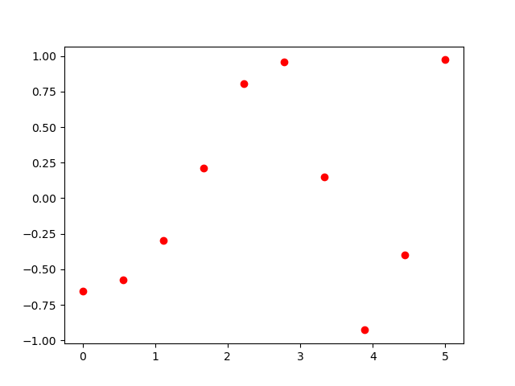

**Task 5:- Interpolation Comparison with Scipy and Matplotlib**

**Python Code:**

from scipy.interpolate import interp1d

import matplotlib.pyplot as plt

import numpy as np

x = np.linspace(2, 10, 10)

y = np.sin(x**2/3+4)

fun1 = interp1d(x, y, kind='linear')

fun2 = interp1d(x, y, kind='cubic')

xnew = np.linspace(3, 5, 30)

plt.plot(x, y, 'o', xnew, fun1(xnew), '-', xnew, fun2(xnew), '--')

plt.legend(['data', 'linear', 'cubic', 'nearest'], loc='best')

plt.show().

**Output:**

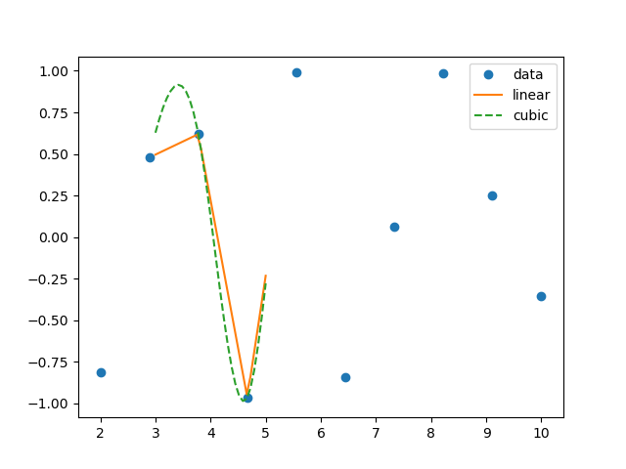

**Task 6:- Linear System Solution and Determinant Calculation using SciPy and NumPy**

**Python Code:**

import numpy as np

from scipy import linalg

import numpy as np

from scipy import linalg

a = np.array([[1, 2, -3], [2, -5, 4], [5, 4, -1]])

b = np.array([[-3], [13], [5]])

x = linalg.solve(a, b)

print(x)

print("\n Checking results,must be zeros")

print(a.dot(x) - b)

A = np.array([[1, 2, 9], [3, 4, 8], [7, 8, 4]])

x = linalg.det(A)

print('Determinant of \n{} \n is {}'.format(A, x))

**Output:**

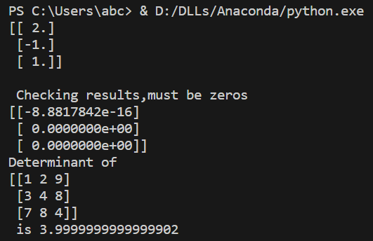

**Task 7:- Calculating Eigenvalues and Eigenvectors of a Matrix using SciPy and NumPy**

**Python Code:**

from scipy import linalg

import numpy as np

A = np.array([[2, 1, -2], [1, 0, 0], [0, 1, 0]])

values, vectors = linalg.eig(A)

print(values)

print(vectors)

**Output:**

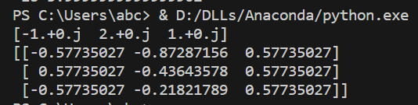

**Task 8:- Displaying a Raccoon Face Image Using Matplotlib**

**Python Code:**

import scipy.misc

import matplotlib.pyplot as plt

face = scipy.misc.face() # returns an image of raccoon

plt.imshow(face)

plt.show()

**Output:**

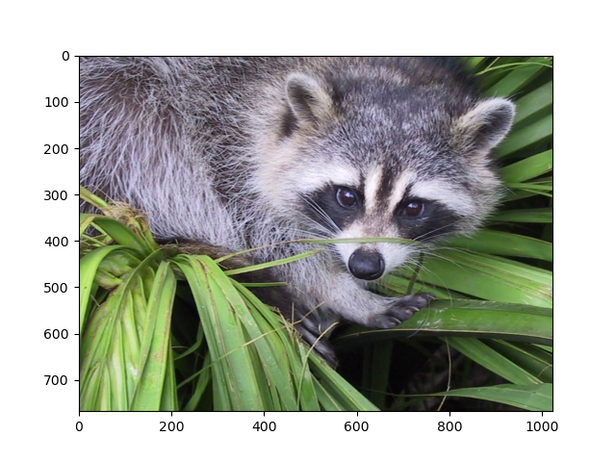

**Task 9:- Image Cropping with SciPy and Matplotlib**

**Python Code:**

import scipy.misc

import matplotlib.pyplot as plt

face = scipy.misc.face() # returns an image of raccoon

lx, ly, channels = face.shape

crop_face = face[int(lx/4):int(-lx/4), int(ly/4):int(-ly/4)]

plt.imshow(crop_face)

plt.show()

**Output:**

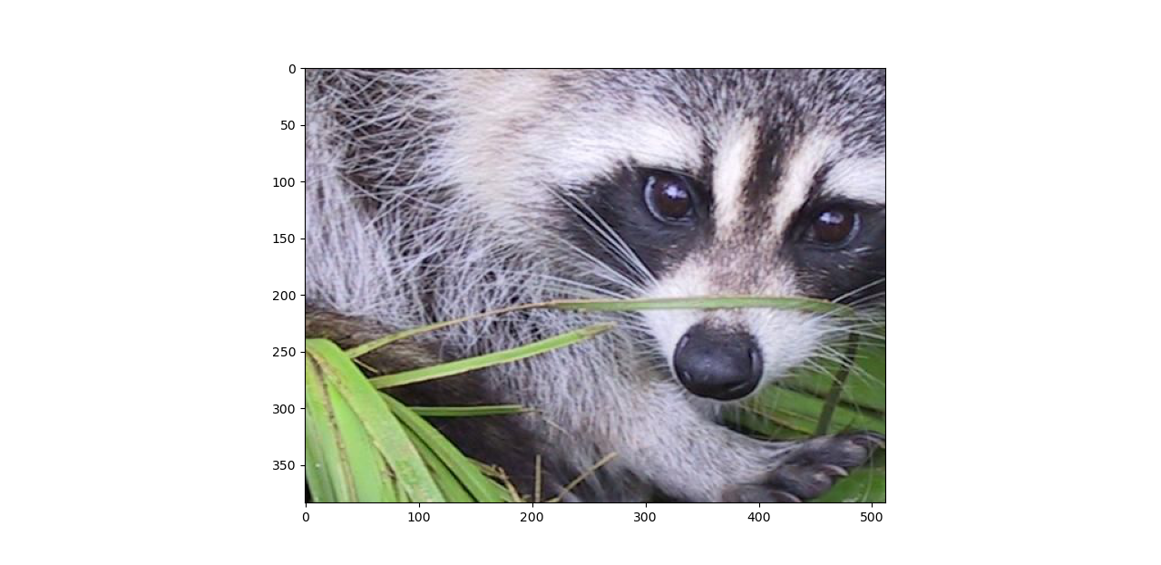

**Task 10:- Image Rotation using SciPy and Matplotlib**

**Python Code:**

from scipy import misc, ndimage

import matplotlib.pyplot as plt

face = misc.face()

rotate_face = ndimage.rotate(face, 180)

plt.imshow(rotate_face)

plt.show()

**Output:**

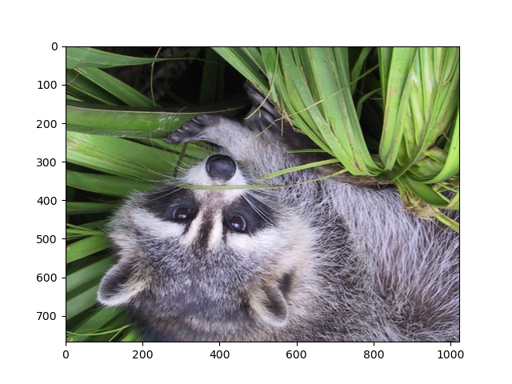

**Task 11:- Image Blurring with Gaussian Filters and Visualization**

**Python Code:**

import scipy as scipy

from scipy import ndimage, misc

import matplotlib.pyplot as plt

face = scipy.misc.face(gray=True)

blurred_face = ndimage.gaussian_filter(face, sigma=3)

very_blurred = ndimage.gaussian_filter(face, sigma=5)

plt.figure(figsize=(9, 3))

plt.subplot(131)

plt.imshow(face, cmap=plt.cm.gray)

plt.axis('off')

plt.subplot(132)

plt.imshow(very_blurred, cmap=plt.cm.gray)

plt.axis('off')

plt.subplot(133)

plt.imshow(blurred_face, cmap=plt.cm.gray)

plt.axis('off')

plt.subplots_adjust(wspace=0, hspace=0., top=0.99, bottom=0.01,

left=0.01, right=0.99)

plt.show()

**Output:**

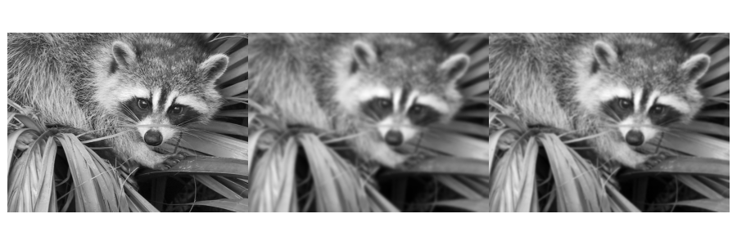

**Task 12:- Image Sharpening with Gaussian Filters**

**Python Code:**

import scipy

from scipy import ndimage

import matplotlib.pyplot as plt

f = scipy.misc.face(gray=True).astype(float)

blurred_f = ndimage.gaussian_filter(f, 3)

filter_blurred_f = ndimage.gaussian_filter(blurred_f, 1)

alpha = 30

sharpened = blurred_f + alpha * (blurred_f - filter_blurred_f)

plt.figure(figsize=(12, 4))

plt.subplot(131)

plt.imshow(f, cmap=plt.cm.gray)

plt.axis('off')

plt.subplot(132)

plt.imshow(blurred_f, cmap=plt.cm.gray)

plt.axis('off')

plt.subplot(133)

plt.imshow(sharpened, cmap=plt.cm.gray)

plt.axis('off')

plt.tight_layout()

plt.show()

**Output:**

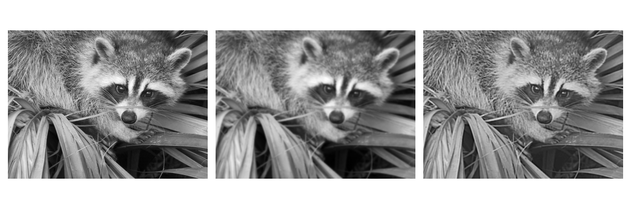

**Task 13:- Image Processing: Rotation, Gaussian Smoothing, and Sobel Filter Application on a Square Image**

**Python Code:**

import numpy as np

from scipy import ndimage

import matplotlib.pyplot as plt

im = np.zeros((256, 256))

im[64:-64, 64:-64] = 1

print(im)

im = ndimage.rotate(im, 15, mode='constant')

im = ndimage.gaussian_filter(im, 8)

sx = ndimage.sobel(im, axis=0, mode='constant')

sy = ndimage.sobel(im, axis=1, mode='constant')

sob = np.hypot(sx, sy)

plt.figure(figsize=(9, 5))

plt.subplot(141)

plt.imshow(im)

plt.axis('off')

plt.title('square', fontsize=20)

plt.subplot(142)

plt.imshow(sob)

plt.axis('off')

plt.title('Sobel filter', fontsize=20)

plt.show()

**Output:**

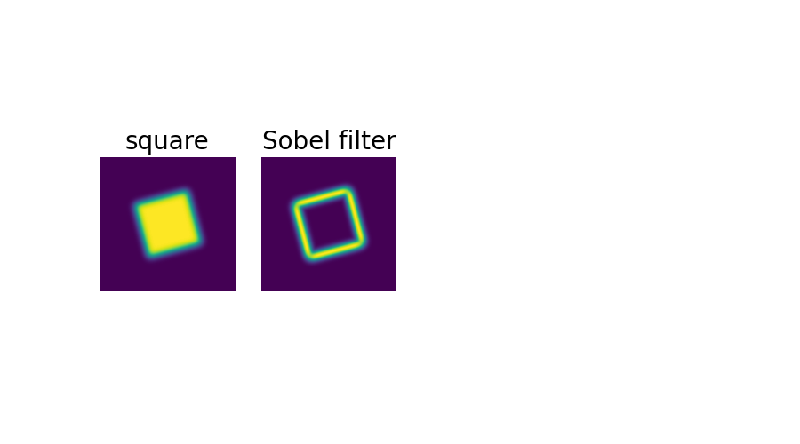

**Post Lab**

**Task 1:- Calculating Inverses and Determinants With scipy.linalg**

**Python Code:**

import numpy as np

from scipy.linalg import inv, det

rows = int(input("Enter The Number Of Rows :- "))

columns = int(input("Enter The Number Of Columns :- "))

A = np.empty((rows, columns))

if(rows == columns ) :

for i in range(0,rows) :

for j in range(0,columns) :

element = int(input(f"Enter The Integer On {i + 1 } th Row and {j + 1 } th Columns :- "))

A[i][j] = element

A_inv = inv(A)

det_A = det(A)

print("Original Matrix A:")

print(A)

print("Inverse of A:")

print(A_inv)

print("Determinant of A:", det_A)

else :

print("Enter Valid Dimmenssions Of A Matrix.")

**Output:**

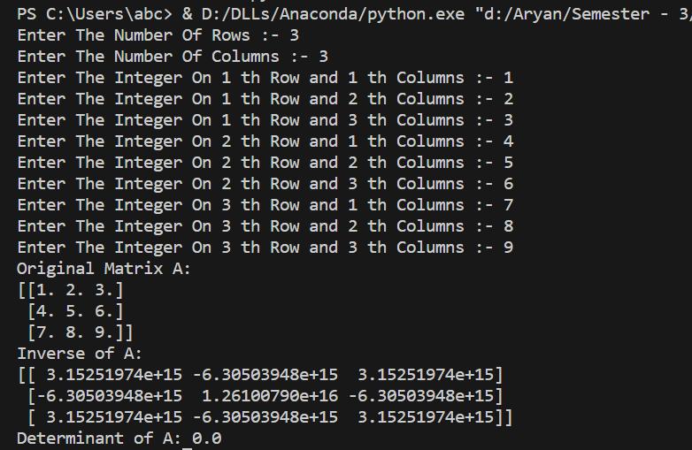

**Task 2:- Calculating Inverses and Determinants With scipy.linalg**

**Python Code:**

import numpy as np

from scipy.interpolate import lagrange

x = np.array([0, 1, 2, 3])

y = np.array([1, 3, 5, 7])

p = lagrange(x, y)

x_new = float(input("Enter The Value Of X to Get Value Of Y For The Function :- Y = P(X) = a0 + a1X + a2X^2 :- "))

y_new = p(x_new)

print(y_new)

**Output:**